Change in coffee consumption habits during The Covid-19 Pandemic in 2020?

Amit Aalok

To answer this question primary data will have to be collected by surveying individuals and analysing the data along with and against secondary data that is already available regarding coffee consumption. This should give a clear picture of any changes that might have taken place and if and how Covid-19 has affected the consumption of coffee.

The secondary data will be collected through research and the primary data will be collected through surveys shared out to a demographic which will include a big range of people but mostly working individuals and students

The primary data collected will predominantly be quantitative data collected through objective questions on the survey as well as some qualitative data collected through subjective questions about the individual’s opinion.

For this solution to function, a large amount of both primary and secondary data will need to be collected from a wide demographic and then properly manipulate the data to effectively visualise it.

The effective functional requirements of the solution are:

* Collections of Primary Data
* Collection of secondary data
* Validation of the data to remove any irrelevant or inappropriate information
* Making sure all the data is 100% confidential and anonymous
* Secure storage of the data
* Competent usage of Spreadsheet and RDBMS
* Testing the data visualisations

The Non-Functional requirements of the solution are

* Distribution of the survey to a wide audience
* Proper documentation of everything needed to complete the solution
* Documentations of the timeline of all the tasks needed to be completed
* Designing the database so that it is easily navigable and manageable
* Making sure the database is secure
* Evaluation of the Testing regime
* Visualisations that do not have any identifying information about the survey takers
* Referencing all the data sources

Constraints of the solution

* Due to the requirement of having the data be completely anonymous more personal questions about coffee drinking could not be asked thus constraining how much personal data can be collected.
* Due to Covid-19 the survey had been handed out online thus limiting the number of people that the survey reached.
* Due to usability reasons, the survey was also constrained to a limited number of questions limiting the amount of information being able to be gathered.
* Due to logistical reasons, the survey had to be closed after a certain period to allow for the data to be analysed.

Scope of the solution

* The solution will address the question of if and how Covid-19 had affected individuals caffeine consumption habits. The solution will focus on roughly how many coffee individuals drank before and after Covid-19 using quantitative data. The solution will also look at how the individuals think they are going in relation to their caffeine consumption habits and their thoughts in caffeine consumption in general and if it correlates to the prior quantitative data. Due to the nature of the survey and the fact that the data collected regarding coffee consumptions per cup per day has an error limit of +/- 2 the resulting analysis of said data will not be able to be precise. The survey will also see how informed individuals are regarding the health ramifications of caffeine.

Survey Questions

1. Do you drink coffee or other caffeinated drinks regularly?
   * Yes
   * No
2. What age bracket best describes your age?
   * 14-19
   * 20-35
   * 35+
3. What is your Gender?
   * Male
   * Female
   * Others
4. Do you drink coffee as a part of your workflow to help you work?
   * Yes
   * No
5. How many cups of coffee did you drink before Covid-19 Restrictions?
   * 0-1
   * 2-3
   * 4-5
   * 5+
6. What was your primary source of coffee during your normal workday?
   * Cafes
   * School/Work Cafeterias
   * Making your own at work/school
   * Taking your own coffee from home
   * Only drinking when home
7. Are you currently studying/working from home?
   * Yes
   * No
8. Where do you get your coffee during Covid-19 restrictions?
   * Cafes (Still trying to support local businesses)
   * Making my own
9. If you are making your own would you say you save money this way?
   * Yes
   * Not really
   * If anything, it’s more expensive
10. Would you say you are more inclined to drink coffee because how easy it is to just make a cup in your kitchen with minimum disruption to your workflow?
    * Very likely
    * Likely
    * Eh
    * Not likely
11. Do you think being safe at home has changed your coffee drinking habits?
    * Yes (I think I consume more coffee)
    * Yes (I think I consume less coffee)
    * No
12. If yes would you say the added stress caused by covid-19 and the extra workload from working from home has contributed to the change?
    * Strongly agree
    * Agree
    * Neither agree nor disagree
    * Disagree
13. How many cups of coffee do you drink during a normal day now? (Following Covid-19 restrictions)
    * 0-1
    * 2-3
    * 4-5
    * 6-7
    * 7+
14. Are you aware of the health risk sustained and excessive intake of caffeine has?
    * Very aware
    * Somewhat
    * I had no idea
15. What do you think is the recommended healthy maximum caffeine intake for your age group?
    * Up to 200 mg of caffeine (2 Normal milk coffees)
    * 000 – 350 mg of caffeine (3 Normal milk coffees)
    * 350 – 450 mg of caffeine (4 Normal milk coffees[1])
    * 450 – 550 mg of caffeine (5 Normal milk coffees)
    * 600+ mg of caffeine (more than 5 normal milk coffees)
16. Would you say any change in your coffee drinking habits due to covid-19 will remain in the near future?
    * Likely
    * Eh
    * Unlikely

\

Infographic

**Evaluation Criteria Development**

|  |  |  |  |  |  |
| --- | --- | --- | --- | --- | --- |
|  | **Design Brief Area** | **Rank** | **Question (Evaluation Criterion)** | **Importance** | **Achievement** |
| **1** | Communication of message | 1 | Does the visualization effectively provide a solution to the research question and communicate it to the audience | So that the audience can better absorb knowledge regarding the research question | Have a good amount of textual information as well as visualizations |
| **2** | Relevance | 2 | Is all the data and information in the infographic relevant to the research question? | So the sudience doesn’t waste their time reading stuff that is irrelevant | Carelefully asses and filter out irrelevant information from the infographic |
| **3** | Clarity | 3 | Is the inforgraphic and the visualitiations clear enough for the audience to understand? | So that the audience can clearly read the information on the infographic | Carefully select phrashes and think out paragraph placement |
| **4** | Readability | 4 | Can the audine understand and read the written text? | If the audience can clearly understand the written text then potentially less text is required | Plenty of white space |
| **5** | Accecibility | 5 | Is the infographic accecible to people with special needs? | So a wider mor diverse audience can be reached with the visualizatuons. | Use proper size fonts. Use clean and distinct colours |

Task 6

Therouygh the design process the raw excel sheet pulled from Microsoft Form was separated into three distinct Sheets or Tables to better organise all the data in to a tble containing all the participants. A table containing all the participants who drink coffee. A table containing all the participants who do not drink coffee. This design choice maked the dataset easier and moreorganised to work will inherently making querries and reports work faster.

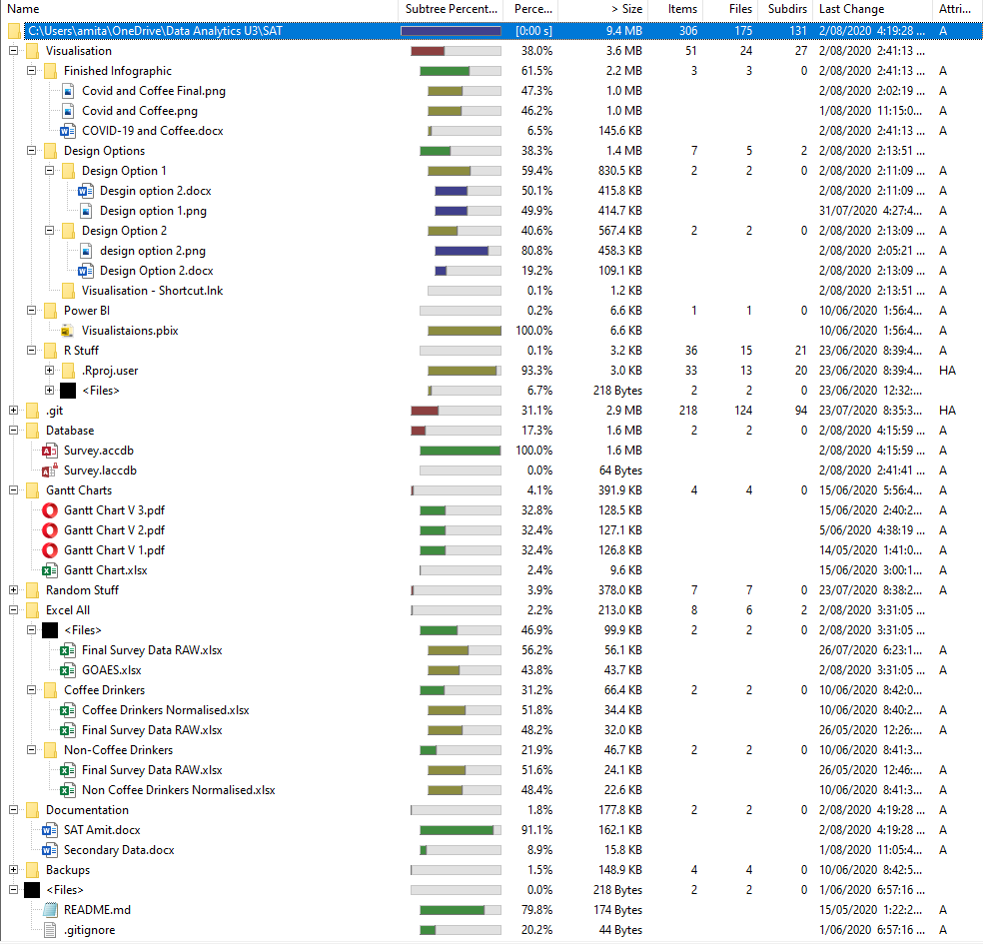**File Management**

All files were created on a personal onedrive folder for the most efficient auto save features and to be able to easily sync between multiple workstations. All the files were also uploaded to a private github repository wich kept a detailed reversible list of everytime a file was change which was then used as a version control system. “.gitignore””readme.md””.git” files are all related to github and are not connected to the actual solution. Every thing was also backed up in to a folder called backups for extra security.

# References

Australian Beverages. 2020. Initiatives, Advocacy & Information - Australian Beverages. [online] Available at: <https://www.australianbeverages.org/initiatives-advocacy-information/> [Accessed 2 June 2020].

Cousins, L., 2020. Is It Safe For Teenagers To Drink Coffee And Energy Drinks? | HCF. [online] Hcf.com.au. Available at: <https://www.hcf.com.au/health-agenda/food-diet/nutrition/is-caffeine-safe-for-teens> [Accessed 2 June 2020].

Foodsafety.com.au. 2020. Is It Safe For Children To Drink Coffee?. [online] Available at: <https://www.foodsafety.com.au/blog/is-it-safe-for-children-to-drink-coffee> [Accessed 2 June 2020].

Granwal, L., 2020. Topic: Coffee Market In Australia. [online] Statista. Available at: <https://www.statista.com/topics/4615/coffee-market-in-australia/> [Accessed 2 June 2020].

Hughes, C., 2020. Australia - Domestic Consumption Of Coffee FY 2019 | Statista. [online] Statista. Available at: <https://www.statista.com/statistics/866543/australia-domestic-consumption-of-coffee/> [Accessed 2 June 2020].

Kelly, C. and Prichard, J., 2016. Demographics, Health, and Risk Behaviors of Young Adults Who Drink Energy Drinks and Coffee Beverages. Journal of Caffeine Research, 6(2), pp.73-81.

Morgan, R., 2016. The Tea Party: Australians Love A Cuppa. [online] Roy Morgan. Available at: <http://www.roymorgan.com/findings/6937-tea-party-australians-love-a-cuppa-201608290942> [Accessed 2 June 2020].

Palmer, T., 2020. Adults Increasingly Worried About Energy Drinks And Children: WA Study. [online] Abc.net.au. Available at: <http://www.abc.net.au/pm/content/2015/s4365445.htm> [Accessed 2 June 2020]..

1. Kelly, C. K., and J. R. Prichard. 2016. "Demographics, Health, and Risk Behaviors of Young Adults Who Drink Energy Drinks and Coffee Beverages."  *J Caffeine Res* 6 (2):73-81. doi: 10.1089/jcr.2015.0027.